**Hotel Management**

Mini-Project Report submitted in partial fulfilment of the requirements of the degree of Bachelor of Engineering by

Shreyas Patil 38

Shantanu Pawar 41

Raju Prajapati 43



Department of Computer Engineering

St. John College of Engineering and Management

University of Mumbai

Guide: Sankusu Sharma

2017-2018

#================= Buttons ================

btnTotal=Button(root,padx=16,pady=8,bd=16,fg="red",font=('arial',16,'bold'),width=10,text="Total",bg="cyan",command=Ref).grid(row=7,column=1)

btnReset=Button(root,padx=16,pady=8,bd=16,fg="red",font=('arial',16,'bold'),width=10,text="Reset",bg="cyan",command=Reset).grid(row=7,column=2)

btnExit=Button(root,padx=16,pady=8,bd=16,fg="red",font=('arial',16,'bold'),width=10,text="Exit",bg="cyan",command=qExit).grid(row=7,column=3)

btnHM=Button(root,padx=16,pady=8,bd=16,fg="red",font=('arial',16,'bold'),width=15,text="Hotel Management",bg="yellow",command=qParse).grid(row=9,column=4)

root.mainloop()

**Output:-**

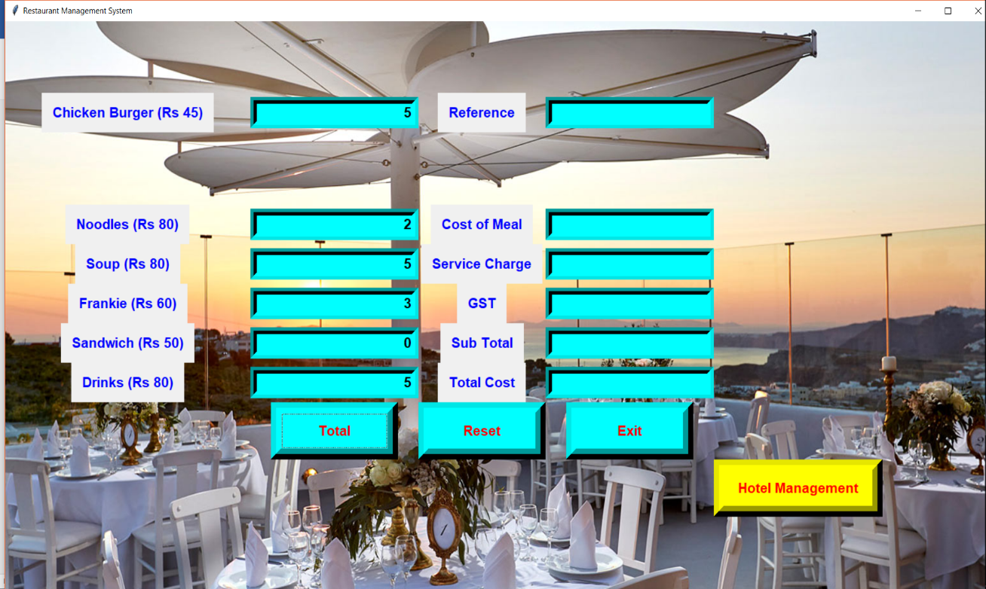

**Figure 1 -** After inputting the desired values in the 1st Billing Window.

**Figure 2 -** On pressing the Total Button and getting the following values.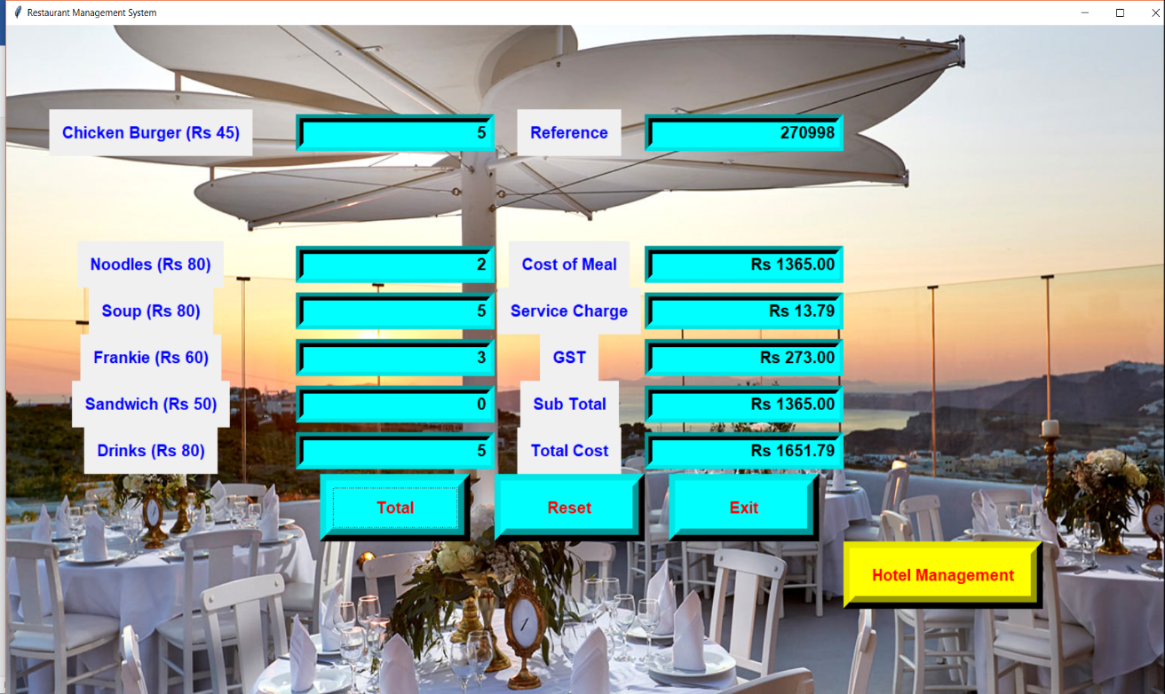

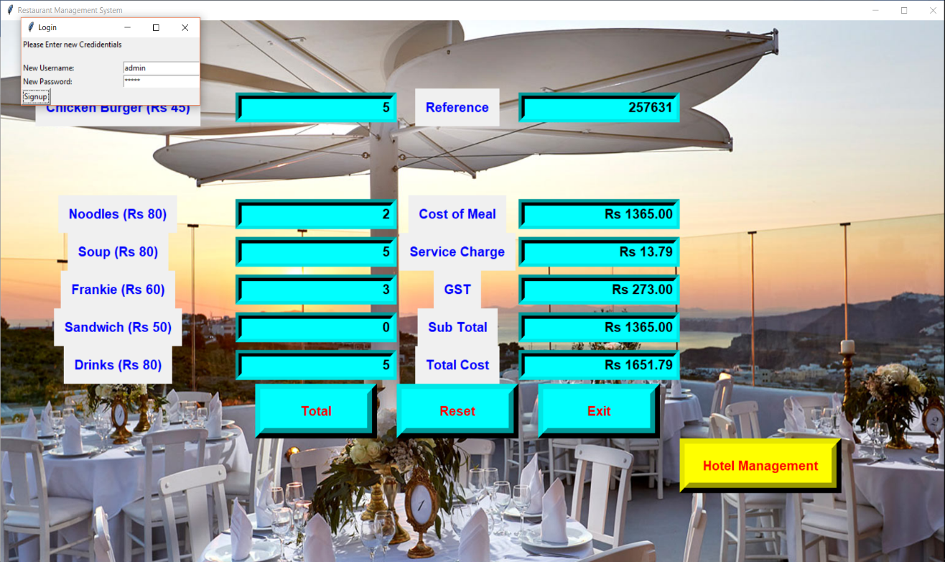

**Figure 3 -** On pressing the “Hotel Management” Tab for Hotel Booking Window we get a “Sign-up” window for a new user.

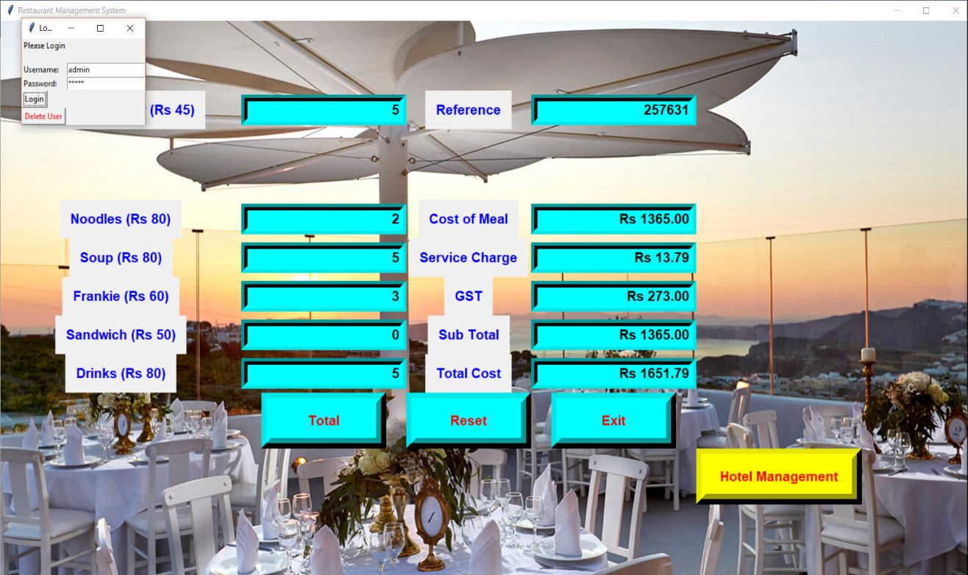

**Figure 4 -** On Signing up and Submitting the data we get a “Login Page”.

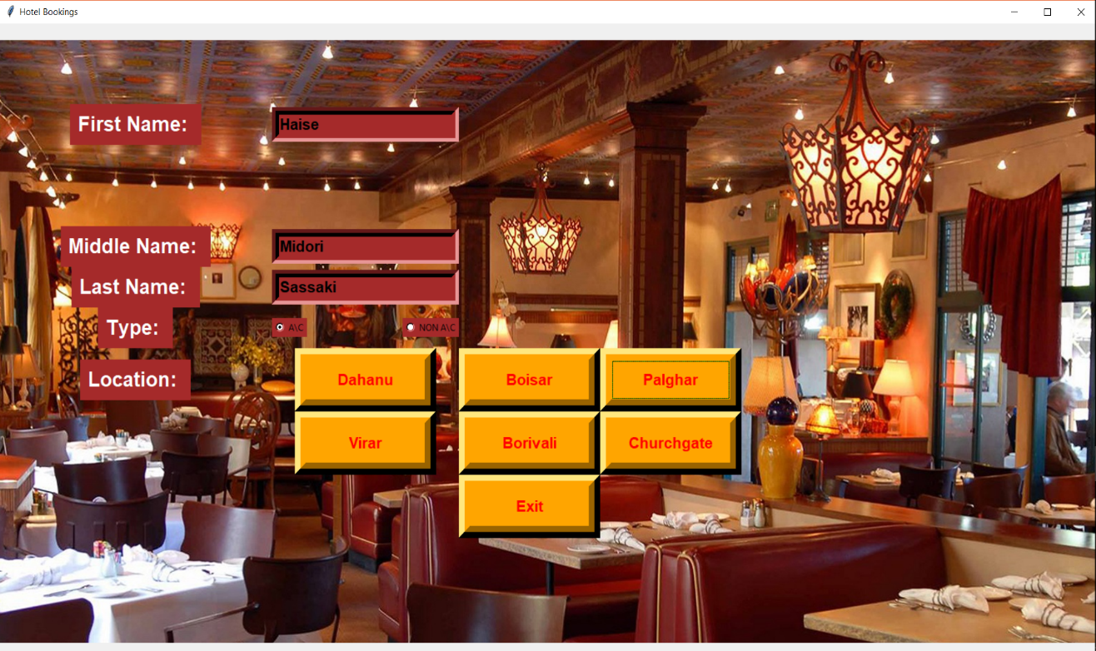

**Figure 5 -** On inputting correct inputted values in “Login Page”, we get 2nd window that is the “Hotel Booking” window. On putting inputting the desired values in 2nd Window.

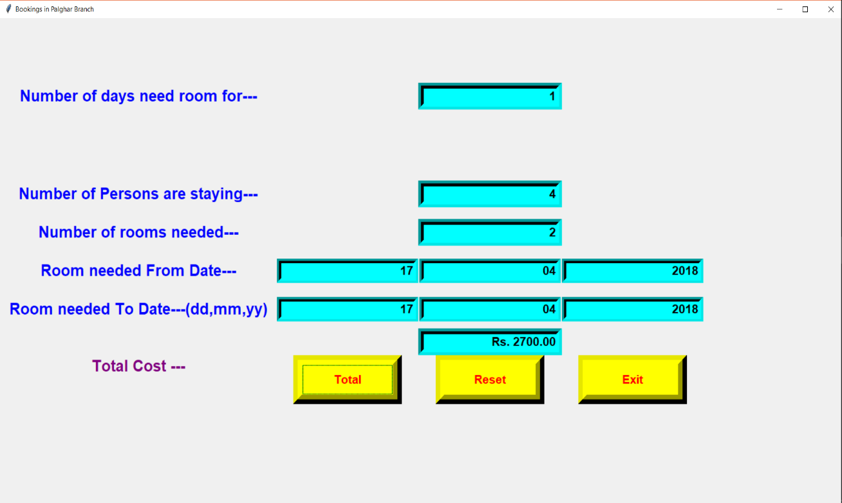 **Figure 6 -** After Selecting the desired location and inputting the values in it.

**Conclusion:**

Thus we have implemented a program to give total amount of a given order and to book a hotel room for a desired number of days using tkinter in python.